**Objectives**

The idea of creating a website of introducing Los Angeles comes from my own personal experience in America. I had my college study at America for three and a half years. While school is out for spring break, Christmas vacation or summer vacation, Los Angeles is a place where I always want to visit and discover excitement. When I started planning my trip in L.A., I hardly ever found a well-organized website that satisfied the needs, preferences and expectations of international students. Traditional travel guide websites often listing all tourist attractions and destinations without focuses to meet general needs and expectations of broad tourists. However, international students are crowds who tend to seek for places of trendy, popular, excitement and fun with lack of information and language barrier. Excluding from students who have accommodations in L.A., most international students would plan a trip at L.A. within one week due to limited college vacation time and low budget.

Therefore, a website that especially addressed the needs of international students crowd who wants to have a visit in L.A. for their school vacation is worth developing.

**Structure**

After the problem and target users are defined, I created a sitemap of listing all the pages that will be on the site. Just like laying a foundation for a house, a sitemap provides me a base to build on. It helps me to decide how to best organize each sections and individual pages in a logical structure. I chose an one page Bootstrap template and the website will be build based on the sitemap below (See Figure 1).

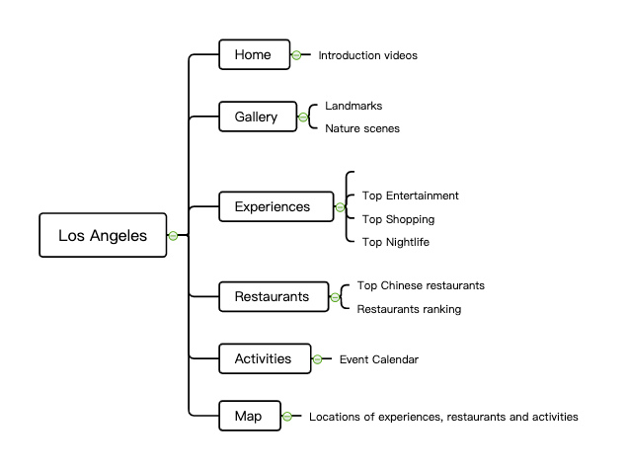

**Skeleton**

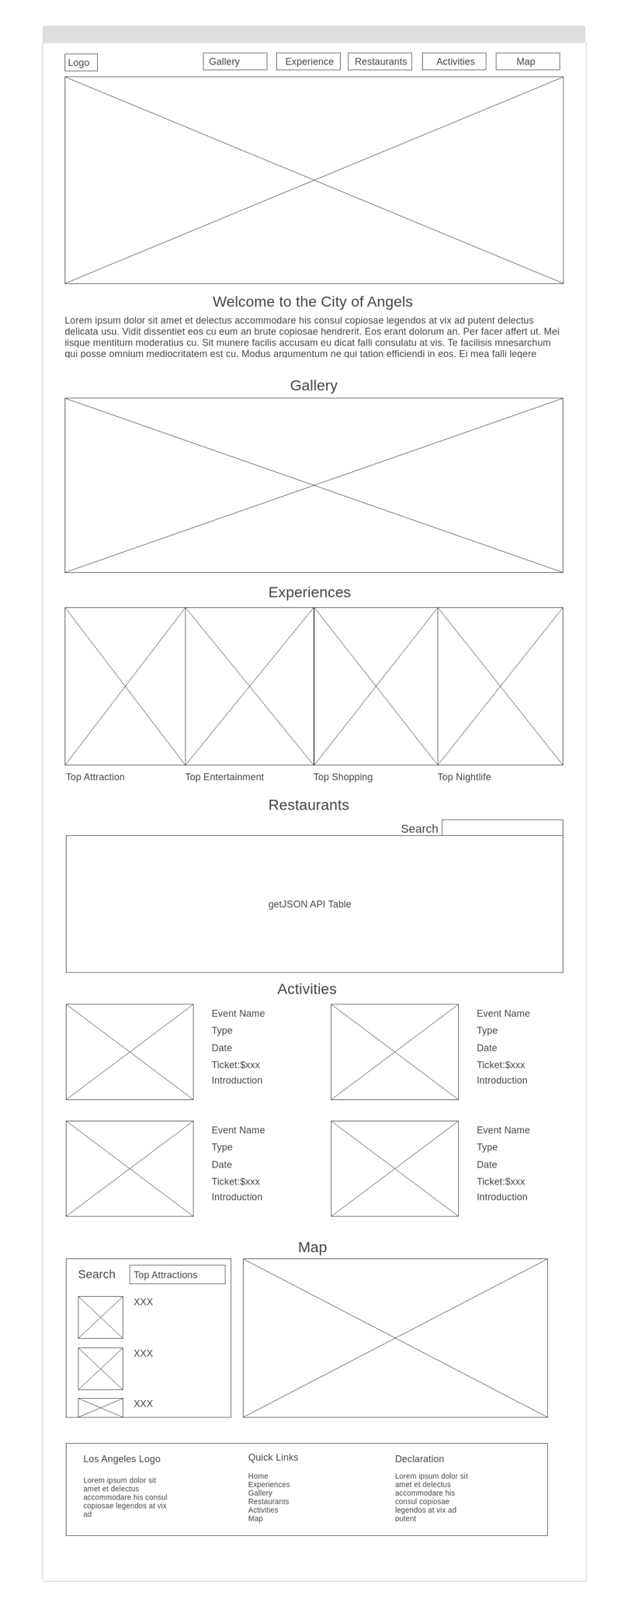Figure 2: Home page

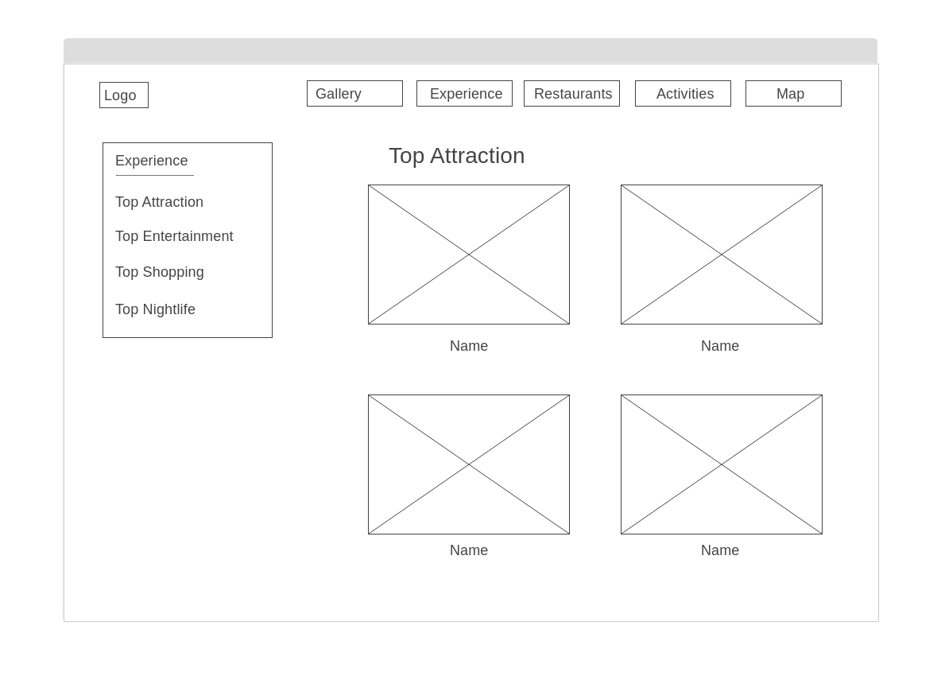

Figure 3: Experience Page

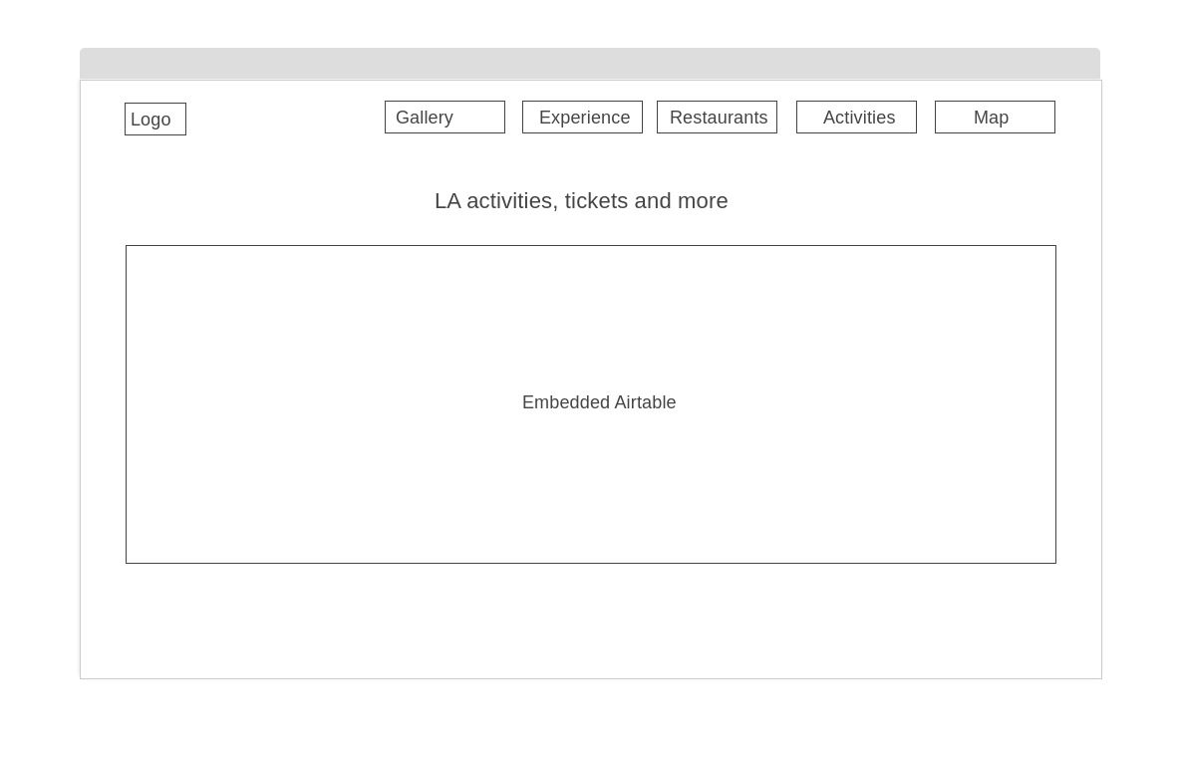

Figure 4: Activities page

After mapping out all the pages that will be displayed on my site, I drew a wireframe to visualize my website design at the structural level and have a preview of the content of each page. As showed above, the home page will include contents of the whole website. Under the navigation bar, users can click to see a video of introducing LA to arise their attentions and interests. With smooth page scrolling, a gallery of some gorgeous LA vibe pictures will be presented. And then by keeping scrolling down, users will get to know what some great experiences they can have in LA such as top attractions, top entertainments, top shopping places and top nightlives. By clicking each category, users can enter to a new page to see more content (see figure 3). The restaurant page will display some recommended food and drinks on LA through a getJSON table. For the activities page, a gallery-view of plentiful fun activities happened in the year of 2020 on LA and popularized among youngsters will be shown. Users can click the button of “see more” to get more enriched information (see figure 4). Contents like pictures, event name, introduction, time, location, price, will be included in this part. Finally, the map section is designed to show where people can have those top experiences. For example, when users select nightlife experiences, location marks of the recommended nightlife places will be displayed on the map.

To evaluate the effectiveness of my website page structure, a usability test was conducted in order to ensure that what I have put together makes sense to users or I may move into visual design. I invited 5 volunteers, among which three are junior college students and 2 are postgraduate students in USA, to answers the following questions:

Q1: What do you think the website is about?

Q2: Is each function clear to you?

Q3: Are there any other functions or contents you expected to see?

According to the test, all volunteers knew the website was some sort of travel guide website and introducing the city of Los Angeles. For the second question, one participants pointed out that the title of “experience” is kind of confusing and better replaced with “things to do” which is intuitive and clear. This reaction inspired me to think deeply of how words can play a factor in navigating user to seek what they want. I adopted this suggestion and made changes to some of the other titles such as “activities” to “find events”. Other participants find each function is pretty clear to them. As for the third question, one suggested to add a page of hotel finding since a trip always started with searching and booking hotels. Another participant recommended to add a function of filtering so that users can filter to find the best results. That participant further explained with examples such as users can filter the activities by price range or type. Although all those suggestions are valuable, they are hard to be realized due to my limited time and web development level.